CREATING DATABASE

1. Open server phpmyadmin
2. Create new database (with your own database name)
3. Create table user
4. Create record with fields (id, name, email and post msg)

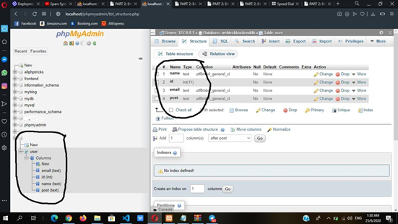

1. Add data to your record
2. View using previous sample code (Sample API from DB from elearning)
3. Change the db name, table and fields in script
4. Get request by id
5. See the output from browser (output should be in JSON Format)

CONFIRM YOUR SLIM SKELETON IS RUNNING

1. Create Application for Slim Framework

(Upload latest code to server) -myapi

1. Point the sites available to the project
2. Restart Nginx
3. Access the skeleton to see the output

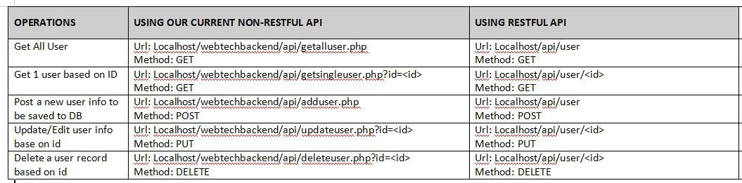

1. Browse https:// your DNS/myapi/
2. You will get this output from browser

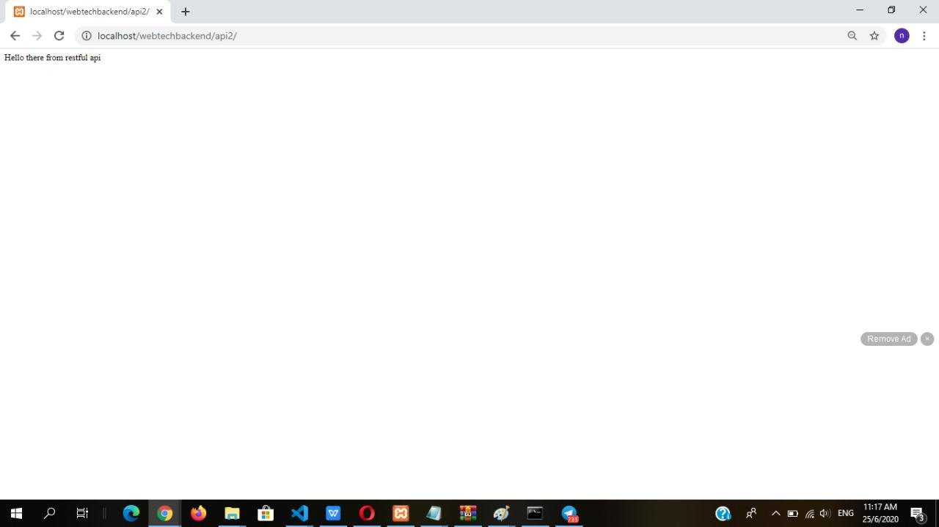

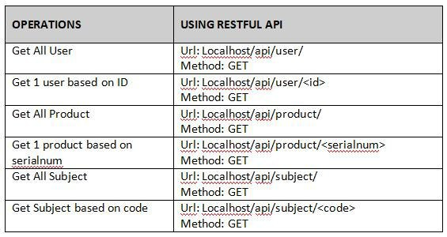

1. You can add routes in your index.php code
2. BUT ONLY GET method can be access from your browser as API Service
3. Other POST method requires POSTMAN

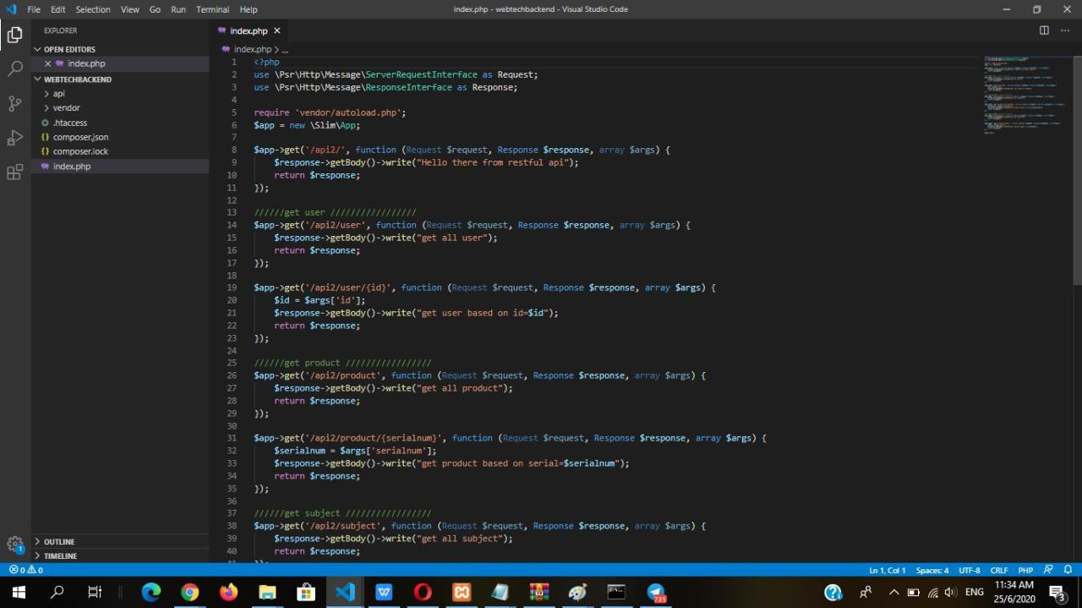

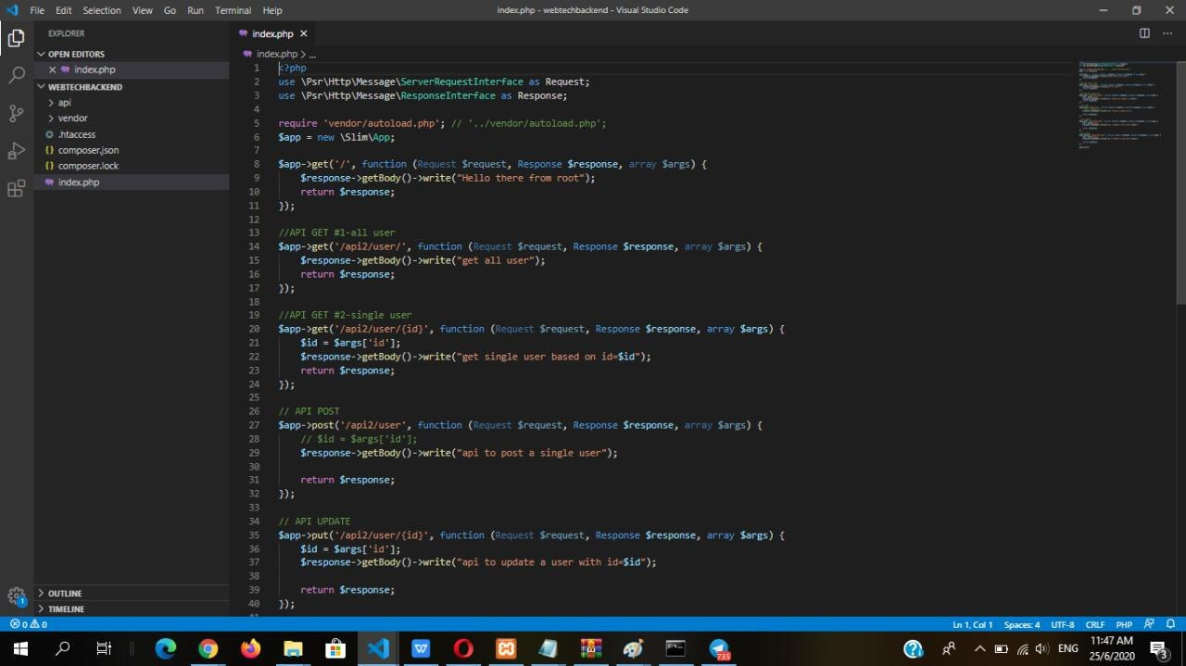

In our code above, to access user, we define 5 routes

Here, lets try to access these 5 api/endpoints that we have created

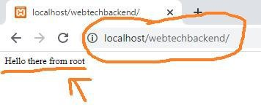

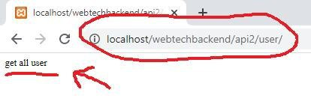

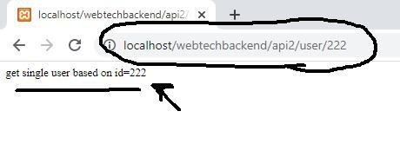

Using a web browser, we can only able to test the GET method. In order to test the POST, PUT and DELETE, we can use several tools (postman, curl, resteasy etc...) here I will use RestEasy

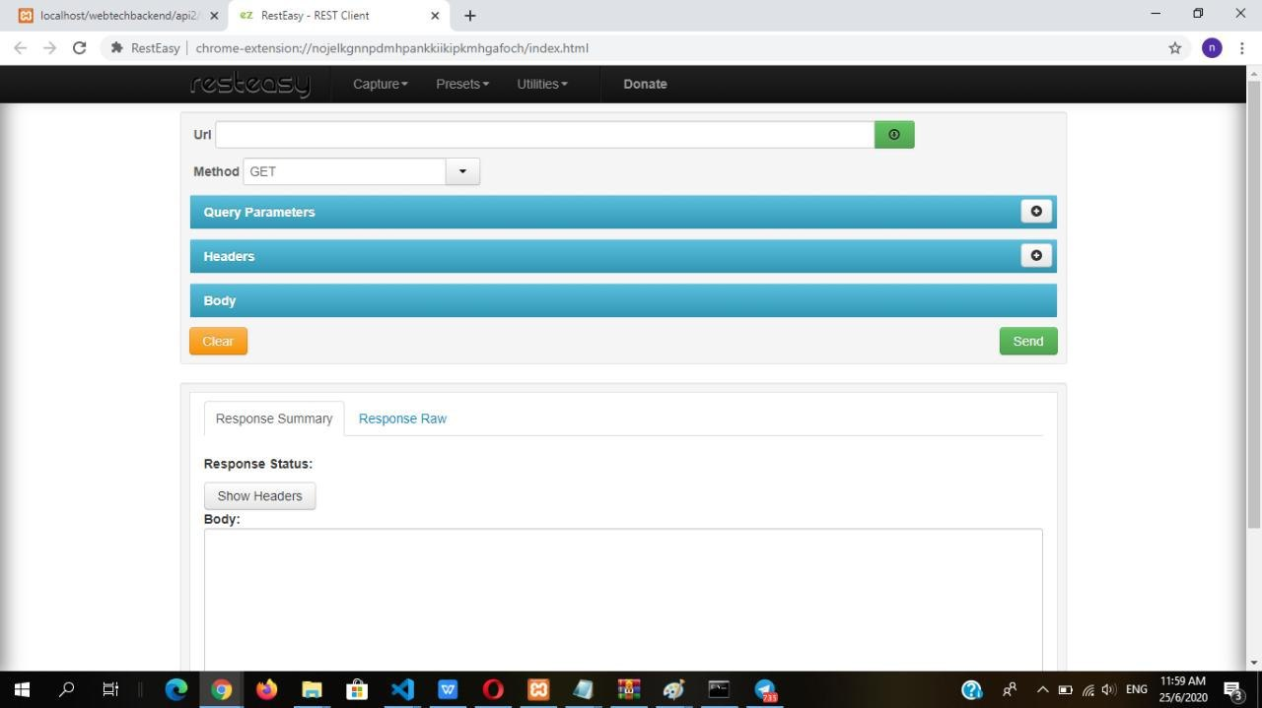

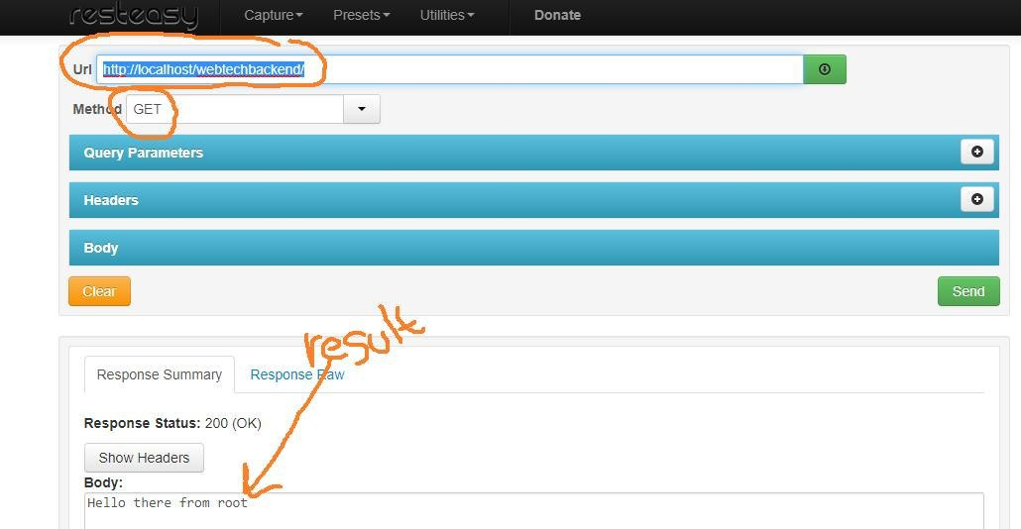

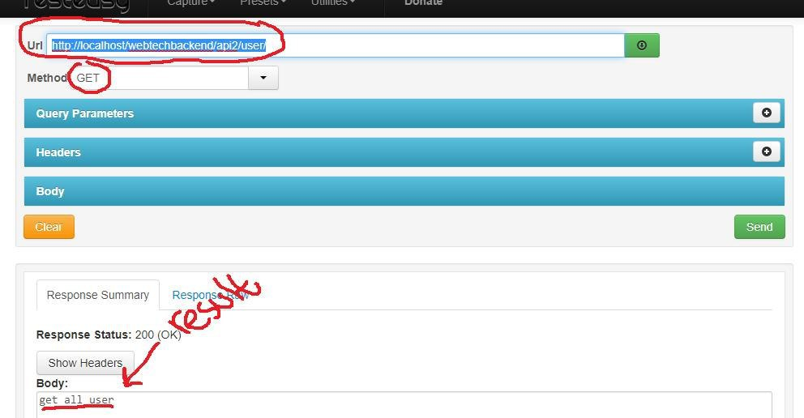

Using RestEasy To get all user

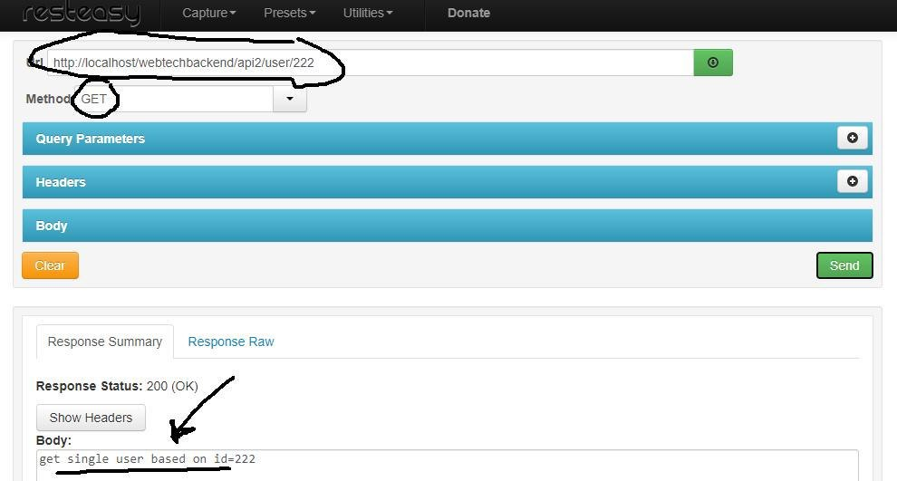

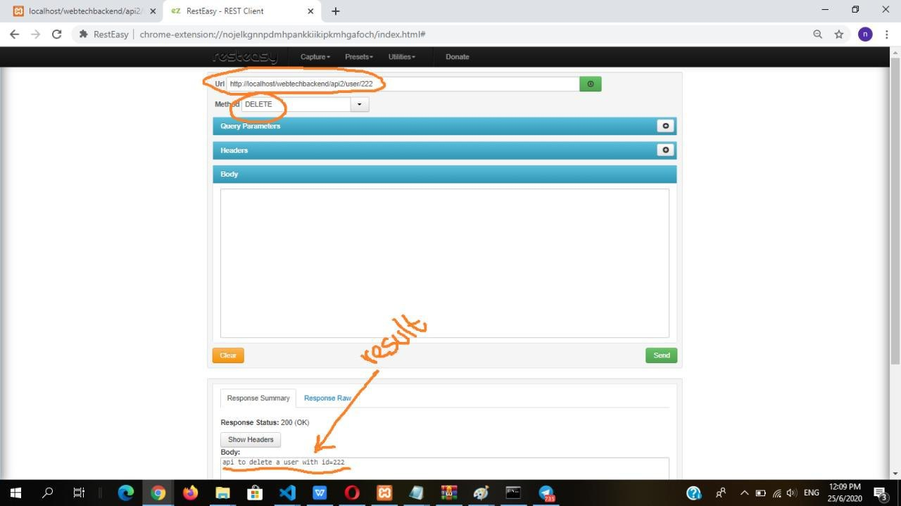

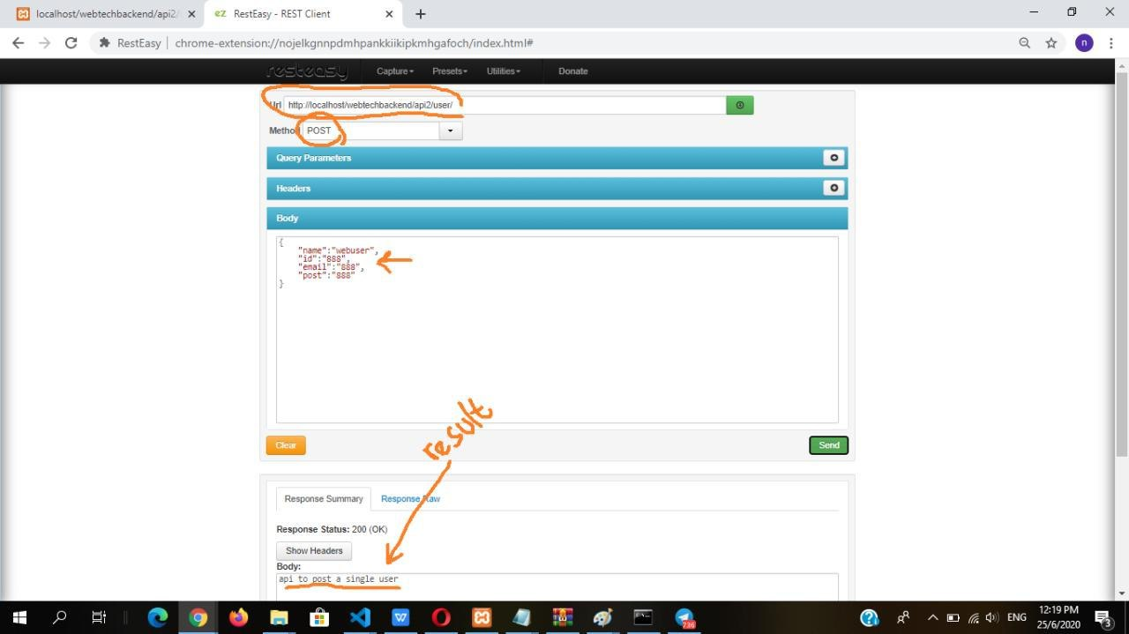

Lets try to call POST

